**VOTING SYSTEM**

A course project report submitted in partial fulfilment of the requirement

of

**PROBLEM SOLVING WITH PROGRAMMING**

by

Vishnuvardhan Reddy (2103A53005)

Charan Sai anche (2103A53001)

Nikhil (2103A51482)

Chandra Reddy (2103A53010)

Under the guidance of

MR.Dr.P.Praveen

Professor, Department of CSE



**ABSTRACT**

The word "vote" means to choose from a list, to elect or to determine. The main goal of voting (in a scenario involving the citizens of a given country) is to come up with leaders of the people's choice. Most countries, Kenya not an exception have problems when it comes to voting.

Some of the problems involved include ridging votes during election, insecure or inaccessible polling stations, inadequate polling materials and also inexperienced personnel.

This online voting/polling system seeks to address the above issues. It should be noted that with this system in place, the users, citizens in this case shall be given ample time during the voting period. They shall also be trained on how to vote online before the election time.

**CONTENTS**

**Chapter No. Title Page No.**

**1 INTRODUCTION** 04

1.1 About the project 04

**2 module discription** 05

2.1 Candidate Module 05

2.2 Commitee Module 05

2.3 Citizen Module 05

2.4 Election Module 06

2.5 Party Module 06

**3. PROJECT IMPLEMENTATION** 07

3.1 source code 07

3.2 Results 13

**4. CONCLUSION 15**

4.1 Conclusion 15

**INTRODUCTION**

***1.1 About the project :-***

**Voting system is a technique. In this system people who have citizenship and whose age is above 18 years and any sex can give his/her vote without going to any physical polling station.There is a database which is aintained in which all the id of voters with complete information is stored.**

**In "VOTING SYSTEM" a voter can use his/her voting right online without any difficulty.Registration is mainly done by the system administrator for security reasons. Citizens seeking registration are expected to contact the system administrator to submit their details. After the validity of them being citizens of India has been confirmed by the system administrator by comparing their details submitted with those in existing databases such as those as the Registrar of Persons, the citizen is then registered as a voter.**

**After registration, the voter is assigned a Voter ID with which he/she can use the system for voting. If invalid/wrong details are submitted, then the citizen is not registered to vote.Not only for political election this used to elect leader for collage.**

**Modules and Description :-**

**2.1 *Candidate Module*:**

**The main purpose for developing this module is to manage the candidate data wise. So all candidates will be managed by admin. Admin can see the list of all the candidate and filter it according to the citizen. It tracks all the information of the candidate.**

**• Admin can manage the candidate**

**• Admin can edit/delete the candidate**

**• Admin can see the list of all candidate and users can see candidate**

***2.2 Commitee Module*:**

**The main purpose for developing this module is to manage the commitee. So all commitee will be managed by admin and users will be able to see the commitee.**

**• Admin can manage the commitee**

**• Admin can edit/delete the commitee**

**• Admin can see the list of all commitee . Users can see commitee**

***2.3 Citizen Module*:**

**The main purpose of this module is provide all the functionality realted to citizen. It tracks all the information of the citizen.**

**• Admin can add new citizen records Admin can see the list of citizen**

**details**

**• Only admin can edit and update the record of the citizen**

**• Admin will be able to delete the records of the citizen**

**2.4 *Election Module*:**

**The main purpose for developing this module is to manage the Election. So all election will be managed by admin.**

**• Admin can manage the election**

**• Admin can edit/delete the election**

**• Admin can see the list of all election**

**• Student can see his election**

***2.5 Party Module*:**

**The main purpose of this module is provide all the functionality realted to party. It shows all the information and details of the party.**

**• Admin can add new party**

**• Admin can see the list of party details**

**• Only admin can edit and update the record of the party**

**PROJECT IMPLEMENTATION :-**

***3.1 source code:***

**#include <stdio.h>**

**#include <stdlib.h>**

**#include<string.h>**

**#define total_no_of_parties**

**#define party_no_1 "A"**

**#define party_no_2 "B"**

**#define party_no_3 "C"**

**#define party_no_4 "D"**

**int vote_Count1 = 0,**

**vote_Count2 = 0,**

**vote_Count3 = 0,**

**vote_Count4 = 0,**

**invalid_votes = 0;**

**void castVote( )**

**{ int choice;**

**printf("\n \n <#> <#> <#> <#> Please chooose your Candidate <#> <#> <#> <#> \n \n");**

**printf("\n 1. %s", party_no_1);**

**printf("\n 2. %s", party_no_2);**

**printf("\n 3. %s", party_no_3);**

**printf("\n 4. %s", party_no_4);**

**printf("\n 5. %s", "None of the above");**

**printf("\n \n Input your choice ( 1 - 4 ) : ");**

**scanf("%d", &choice);**

**switch (choice)**

**{ case 1:**

**vote_Count1++;**

**break;**

**case 2:**

**vote_Count2++;**

**break;**

**case 3:**

**vote_Count3++;**

**break;**

**case 4:**

**vote_Count4++;**

**break;**

**case 5:**

**invalid_votes++;**

**break;**

**default:**

**printf(" \n Error: Wrong Chocie !! Please retry");**

**getchar();**

**}**

**printf(" \n Thanks for your vote !!");**

**}**

**void votesCount( )**

**{ printf("\n \n ##### Voting Statics #####");**

**printf("\n %s - %d", party_no_1, vote_Count1);**

**printf("\n %s - %d", party_no_2, vote_Count2);**

**printf("\n %s - %d", party_no_3, vote_Count3);**

**printf("\n %s - %d", party_no_4, vote_Count4);**

**printf("\n %s - %d", "Spoiled Votes", invalid_votes);**

**}**

**void getLeadingCandiate( )**

**{ printf("\n \n ##### Leading Candiate #####");**

**if(vote_Count1 > vote_Count2 && vote_Count1 > vote_Count3 && vote_Count1 > vote_Count4)**

**{ printf("The Leading Candiate is %s", party_no_1);**

**}**

**else if(vote_Count2 > vote_Count1 && vote_Count2 > vote_Count3 && vote_Count2 > vote_Count4)**

**{ printf("The Leading Candiate is %s", party_no_2);**

**}**

**else if(vote_Count3 > vote_Count2 && vote_Count3 > vote_Count1 && vote_Count3 > vote_Count4)**

**{ printf("The Leading Candiate is %s", party_no_3);**

**}**

**else if(vote_Count4 > vote_Count2 && vote_Count4> vote_Count3 && vote_Count4 > vote_Count1)**

**{ printf("The Leading Candiate is %s", party_no_4);**

**}**

**else**

**{ printf("+++++++++++++ Warning!!!!!!!!! No Win-Win Situation ++++++++++++++");**

**}**

**}**

**int main( )**

**{ printf("\t\t\t###########################################################################");**

**printf("\n\t\t\t############ ############");**

**printf("\n\t\t\t############ Voting Machine ############");**

**printf("\n\t\t\t############ ############");**

**printf("\n\t\t\t###########################################################################");**

**printf("\n\t\t\t---------------------------------------------------------------------------\n");**

**char username[15];**

**char password[12];**

**printf("Enter your username:\n");**

**scanf("%s",&username);**

**printf("Enter your password:\n");**

**scanf("%s",&password);**

**if(strcmp(username,"group6")==0)**

**{ if(strcmp(password,"123")==0)**

**{**

**printf("\nWelcome.Login Success!");**

**int choice;**

**do{**

**printf("\n \n ###### WELCOME TO ELECTION / VOTING 2022 A.D ######");**

**printf("\n \n 1. Cast the Vote.");**

**printf("\n \n 2. Find the Vote Count.");**

**printf("\n \n 3. Find the Leading Candidate.");**

**printf("\n \n 0. Exit.");**

**printf("\n \n Please Enter Your Choice : ");**

**scanf("%d", &choice);**

**switch(choice)**

**{ case 1:**

**castVote( );**

**break;**

**case 2:**

**votesCount( );**

**break;**

**case 3:**

**getLeadingCandiate();**

**break;**

**default:**

**printf("\n Error: Invalid Choice !!!");**

**}**

**}**

**while (choice!=0);**

**}**

**else**

**{ printf("\nwrong password\n or username");**

**main( );**

**}**

**}**

**getchar( );**

**}**

***3.2 Results :-***

**• This shows the open page for voting and its shows several options to choose*.***

***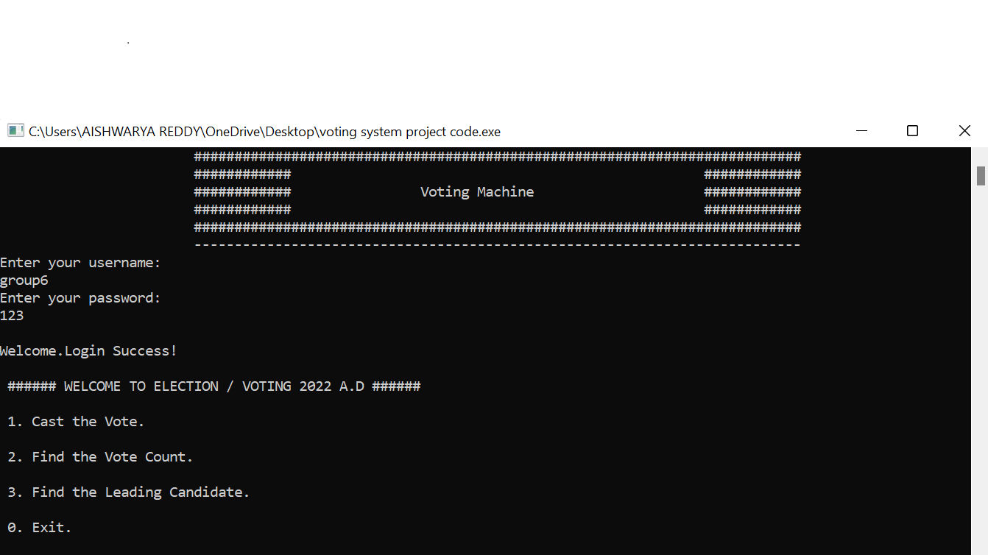*• In this image we have selected 1st option to vote so that we can vote the candidate we whant to.**

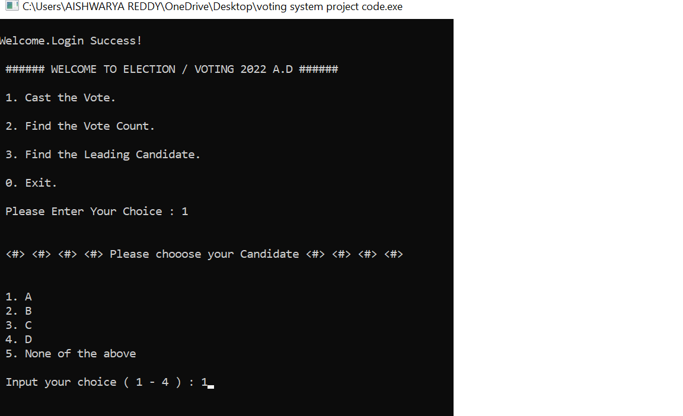

**• By using 2nd option we can see the no.of vote did a candidate have.**

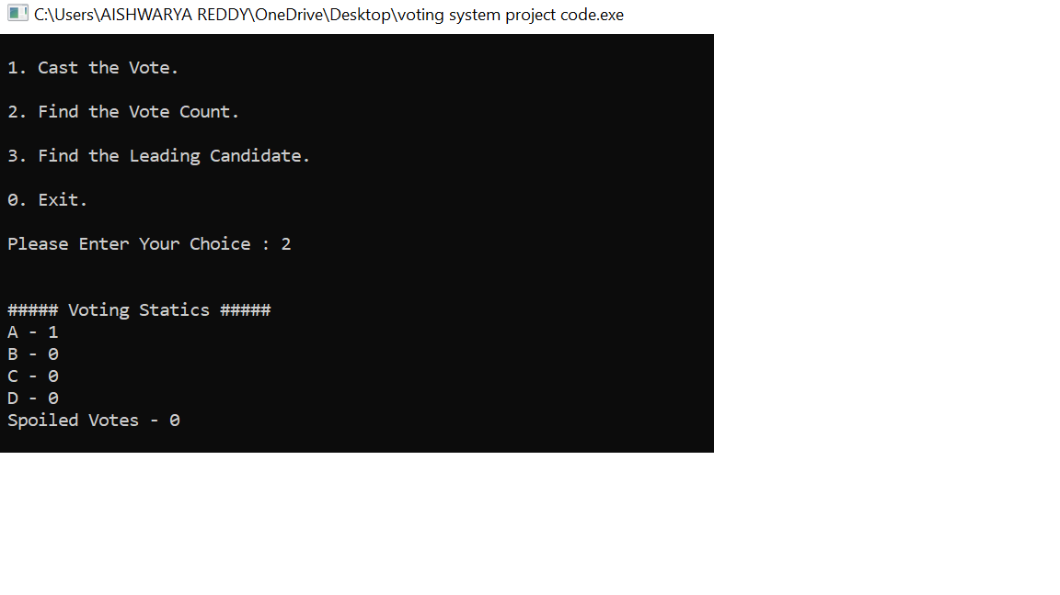

**• By 3rd option we will get to know that which candidate is leading.**

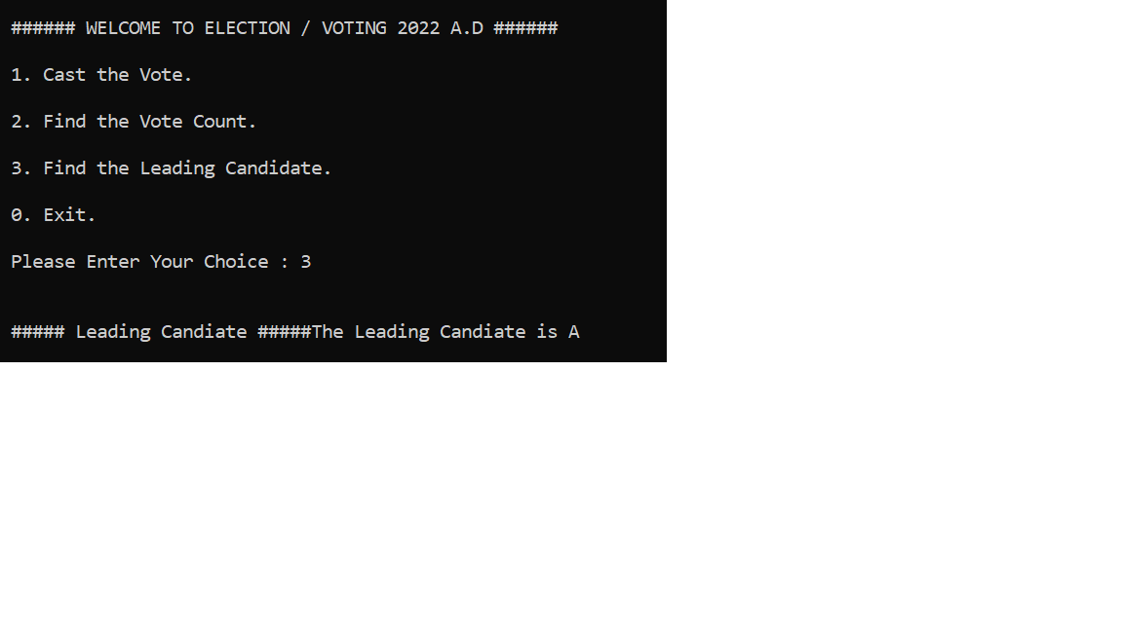

**conclusion**

**This Voting system will manage the Voter's information by which voter can login and use his voting rights. The system will incorporate all features of Voting system. It provides the tools for maintaining voter's vote to every party and it count total no. of vates of every party. There is a database in which all the names of voter with complete information is stored.**

**In this user who is above 18 year's register his/her information on the database and when he/she want to vote he/she has to login by his id and password and can vote to any party only single time. Voting detail store in database and the result is displayed by calculation. By this voting system percentage of voting is increases. It decreases the cost and time of voting process. It is very easy to use and it is vary less time consuming.**